**Digital Content Assembly Tool**

**Reports Guide**

Version 1.0

# Revision History

|  |  |  |  |  |  |  |  |  |
| --- | --- | --- | --- | --- | --- | --- | --- | --- |
| |  |  |  |  | | --- | --- | --- | --- | | **Date** | **Description** | **Author** | **Version** | | 2/25/2013 | Initial draft | DCAT Team | 1.0 | |

Contents

Revision History 2

Purpose 4

1-Sco Reports: 5

2-Asset Reports: 11

Limitations and Constraints 15

Technical Requirements 15

# Purpose

The Digital Content Assembly Tool will allow for content objects to be assembled and deployed in the form of HTML5 compatible documents by content creators. A content object is a group of content pages or screens, which contain interactive and non-interactive content that can be navigated through in a linear fashion. Through the use of HTML5 technology, content objects will be able to be consumed through a continually growing number of consumer devices including mobile phones and tablets.

The reports guide is a Document which explains how to fetch reports from DCAT. Report is used to display all the scos of different projects, their properties in tabular format like Project Name, ScoId, Sco Title, Sco Type, Sco State, Asset Complete %, Last Modified by, Last Modified At. We can also modify metadata, edit content, preview and add comments to the scos.

Asset Report is used to show the assets name, asset status and dcat path of those assets.

**Report Use Cases:**

## 1-Sco Reports:

Step 1: Login into DCAT Application.

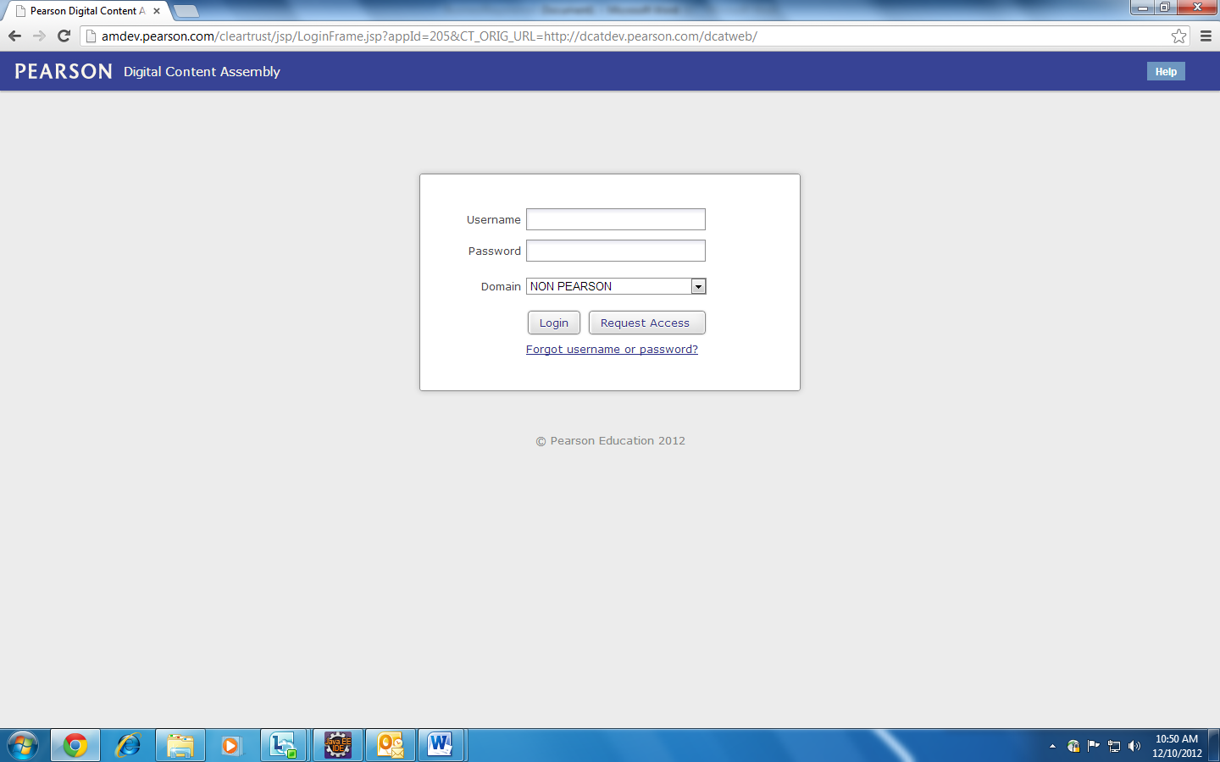

Step 2: Enter the Username and Password (the user which exists in DCAT) and then click on Login Button to login into DCAT Application.

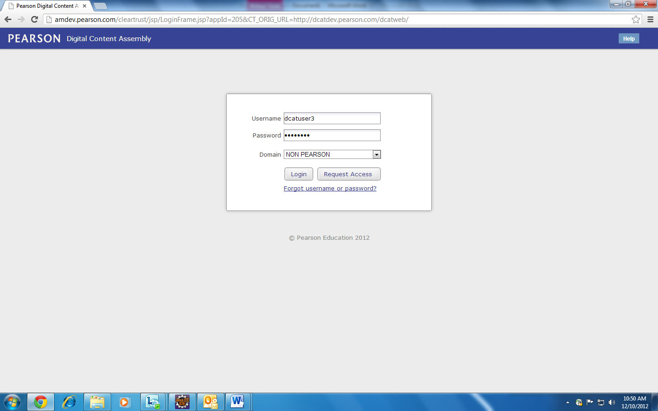

Step 3: In the header we can see that the user name (through which we have loggedIn) is displayed along with the Admin link and logout link. Just below that there is a link for REPORTS.

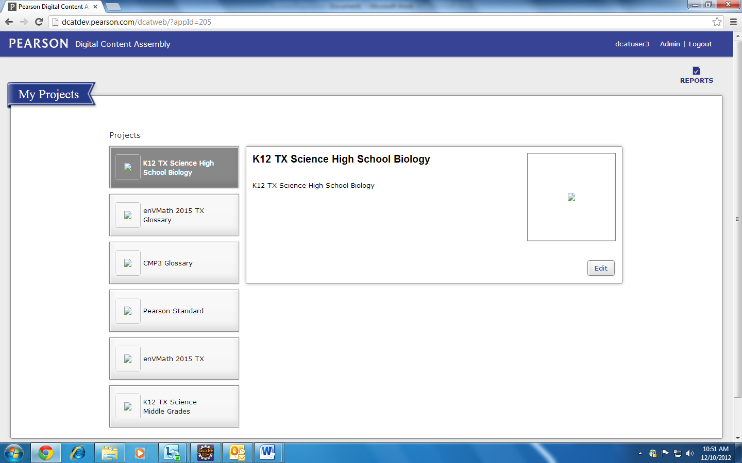

Step 4: Now click on REPORTS link to generate generic report (Includes scos of all projects).

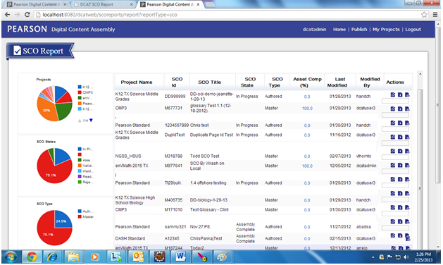

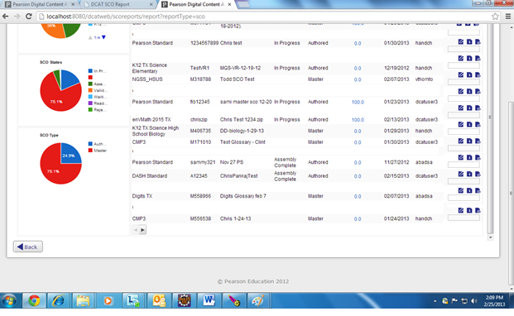

Step 5: When we click on back button, the user is directed back to MyProject screen.

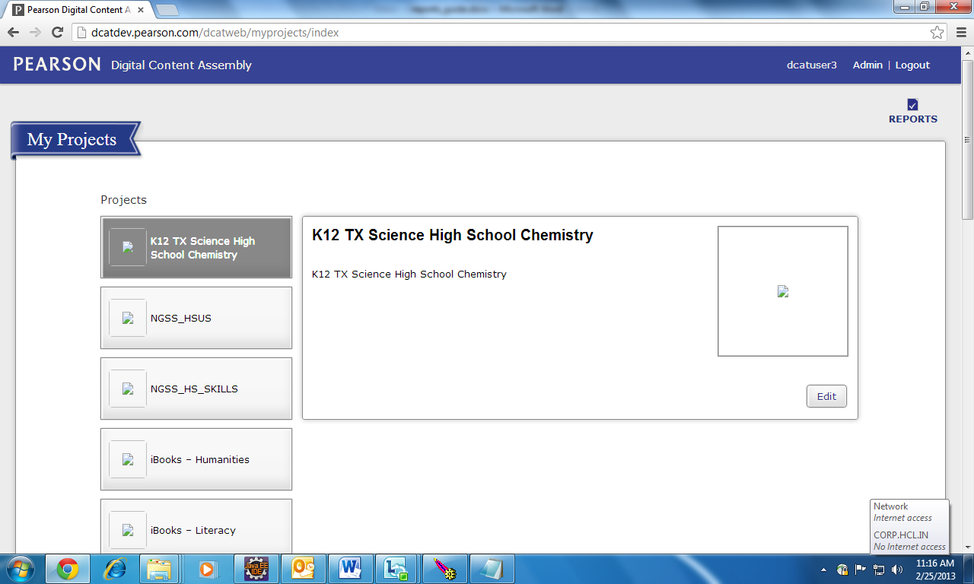

Step 6: When we click on edit content link, the user is directed to edit content screen.

The user can make changes and click on finish button, the user is directed back to reports page only.

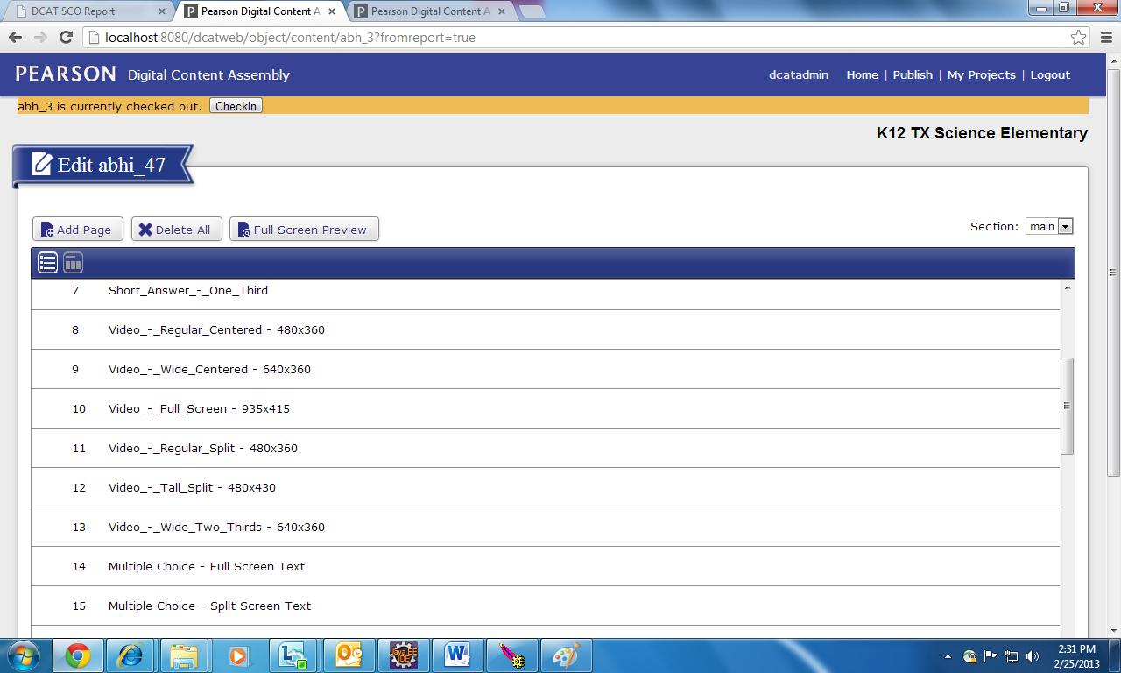

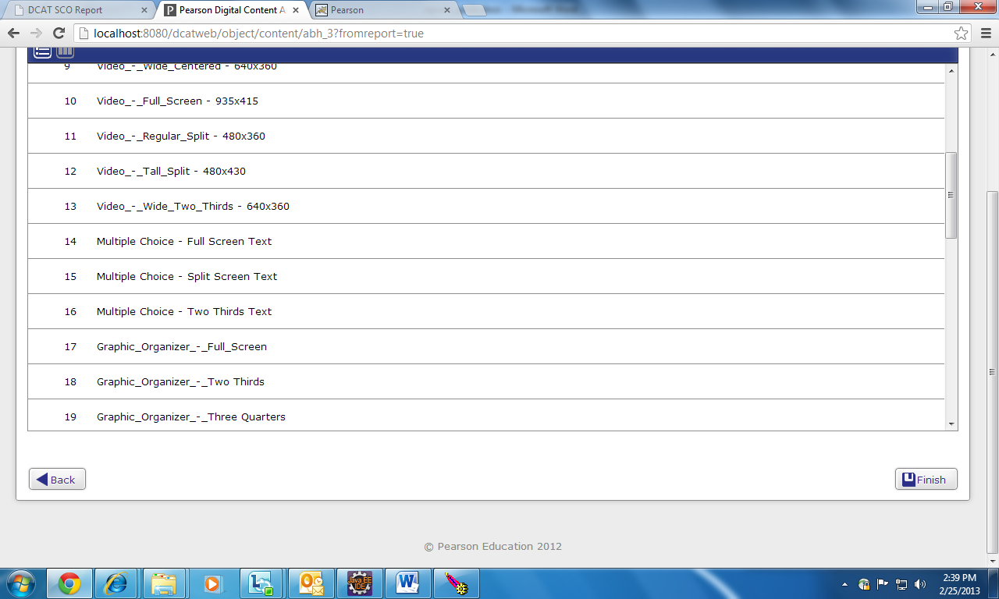

Step 7: When we click on modify metadata link, the user is directed to modify metadata screen.

The user can make changes and click on ‘Save and Finish’ button, the user is directed back to reports page only.

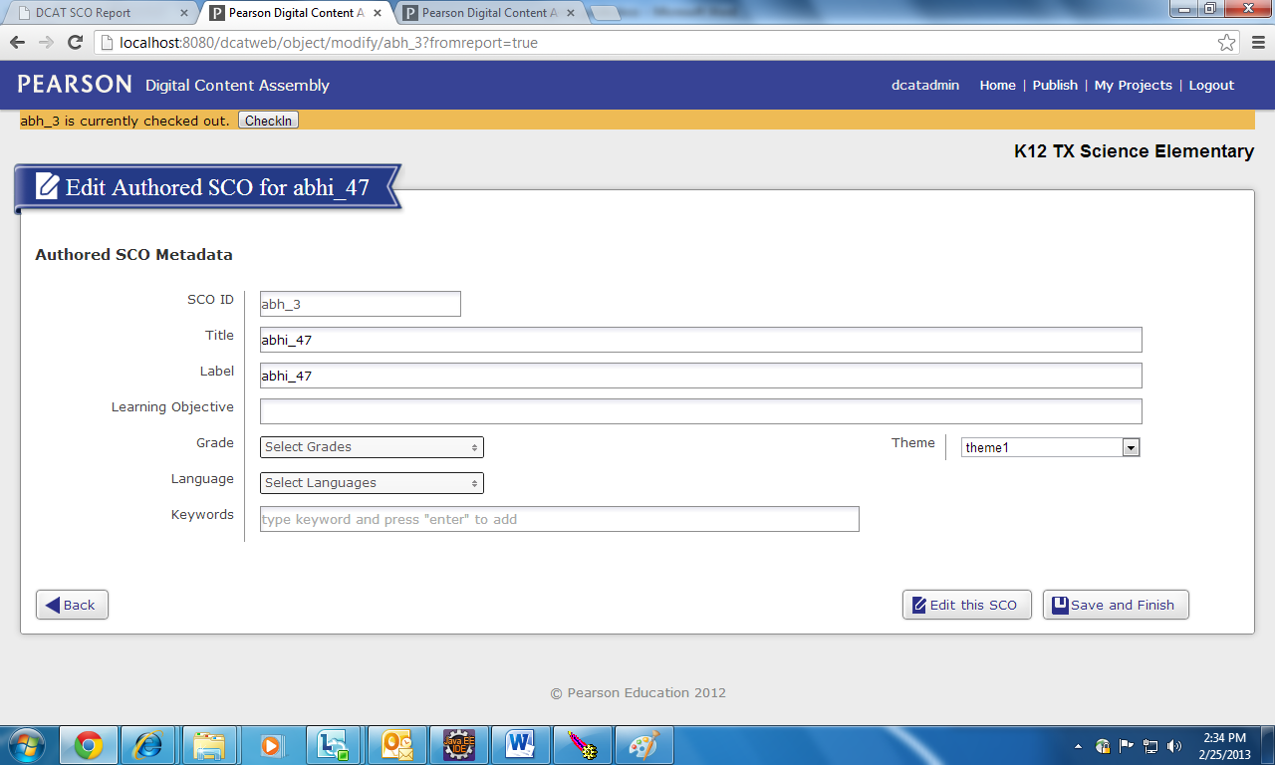

Step 8: When we click on preview link, the user is directed to preview screen.

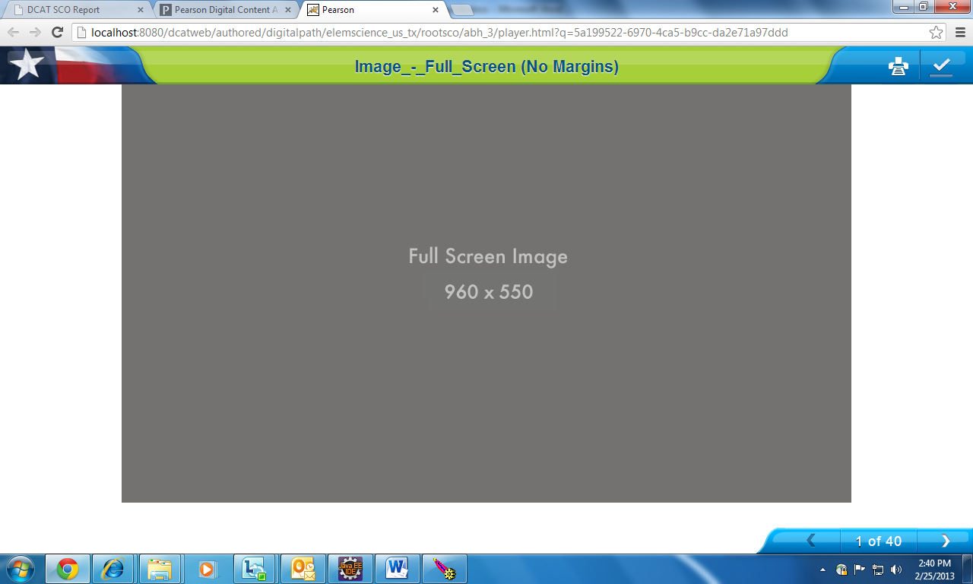

Step 9: When we click on comment link, the user can add comments to sco.

The user can make changes and click on ‘Back’ button, the user is directed back to reports page only.

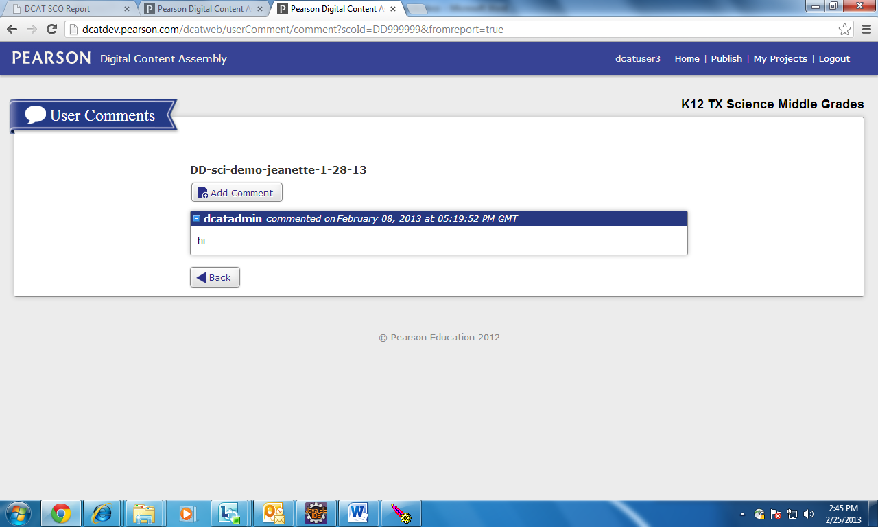

## 2-Asset Reports:

Step 1: Login into DCAT Application.



Step 2: Enter the Username and Password (the user which exists in DCAT) and then click on Login Button to login into DCAT Application.



Step 3: In the header we can see that the user name (through which we have loggedIn) is displayed along with the Admin link and logout link. Just below that there is a link for REPORTS.



Step 4: Now click on REPORTS link to generate generic report (Includes scos of all projects).

Step 5: Now click on Asset Comp(%) column to view the asset report.

It shows the asset name, asset status and dcatpath of asset.

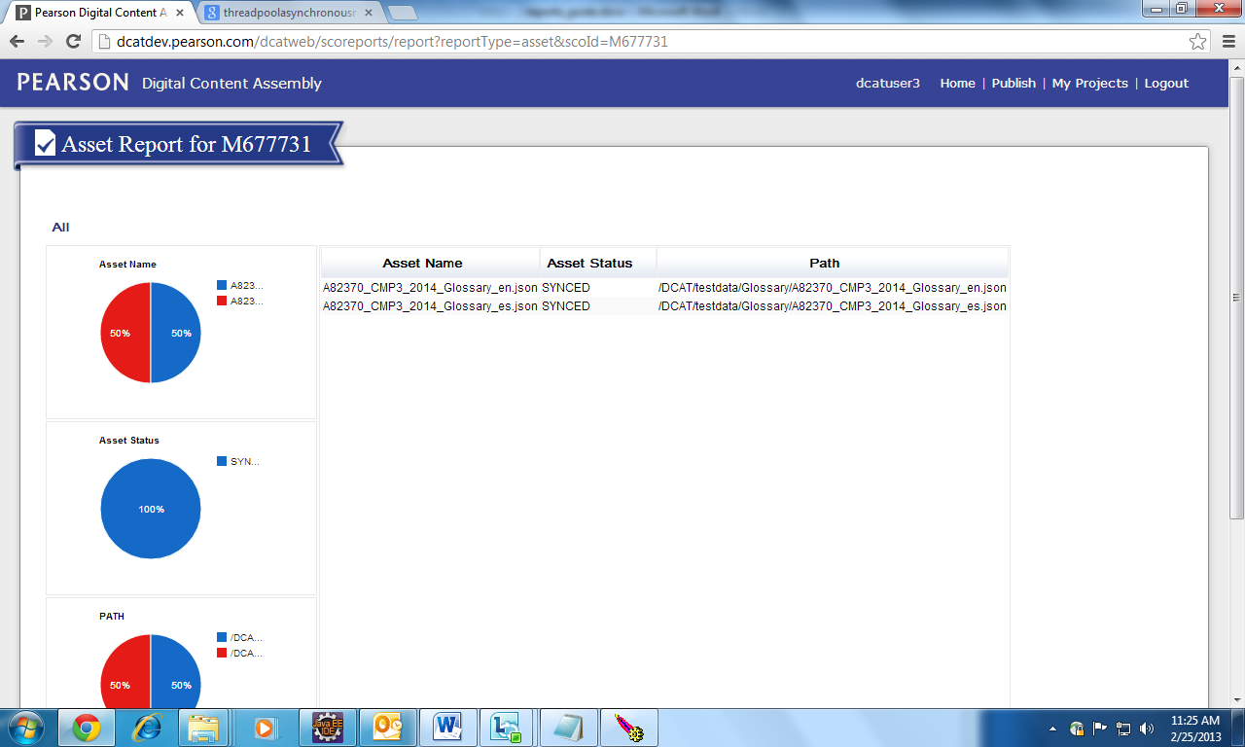

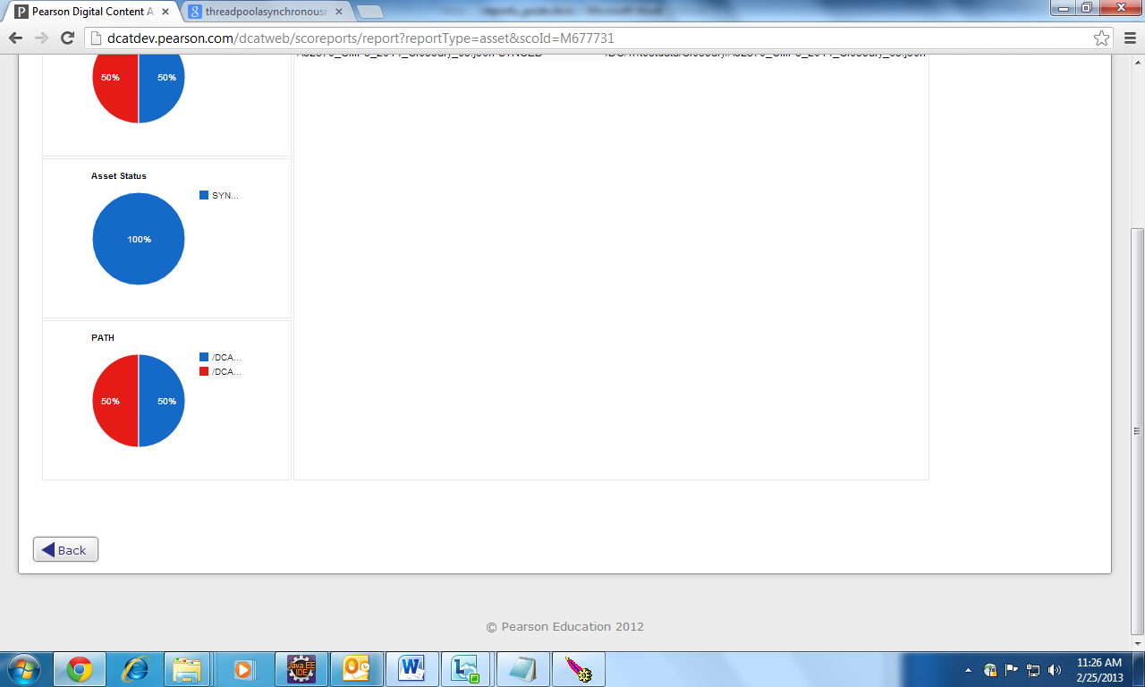

Step 6: When we click on back button present at the asset report screen, we are directed back to sco reports screen.



# Limitations and Constraints

NA

# Technical Requirements

**[Back-end Technologies]**

* Server: Apache
* Application Server: Apache Tomcat
* Platform: J2EE
* RDBMS: Oracle

**[Front-end Technologies]**

* Platform:
* HTML5
* CSS2/3
* Javascript
* JQuery
* JQuery UI
* Moo4q (Mootools OOP for JQuery)

**Supported Clients:**

1. IE 8+ (IE 9+ for HTML5 editing)
2. Firefox 3.5+
3. Safari 4+

Chrome